**Forgot Password**  [**https://citria.org/forgot-password**](https://citria.org/forgot-password)

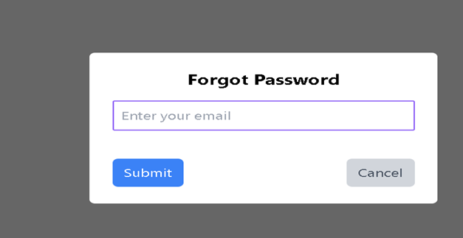

The ForgotPassword component is a React component responsible for handling the process of resetting a user's password when they have forgotten it. Let's break down its key features and functionality.

1. State and Hooks:

The component uses React hooks like useState and useContext to manage state.

State variables include email (to store the user's email), loading (to track loading state), and showToast (to display notifications).

2. Form Handling:

The handleForgotPassword function is triggered on form submission.

It checks if the email is provided and makes an asynchronous POST request to the server (axios.post) to initiate the password reset process.

It handles success and error responses, updating the UI accordingly.

3. UI/UX and Styling:

The component is styled using Tailwind CSS, providing a clean and responsive design.

It includes a page title (PageTitle component) for better organization.

4. Routing and Navigation:

The useNavigate hook is used for programmatic navigation after successful actions.

Users can cancel the password reset process and return to the sign-in page by clicking the "Cancel" link (Link to={'/sign-in'}).

5. External Components:

The component includes the Spinner component, which is displayed during loading operations, providing feedback to the user.

6. API Interaction:

The component communicates with the server via Axios to trigger the forgot password functionality.

Success and error responses from the server are handled, and appropriate notifications are displayed to the user.

7. Notification Display:

Notifications are displayed to the user using the showToast function from the context.

8. Form Structure:

The form includes an input field for the user's email and buttons to submit the form or cancel the process.

9. Responsive Design:

The component is designed to be responsive, ensuring a consistent user experience across different devices.

After clicking on send button you will receive an password reset mail like below.

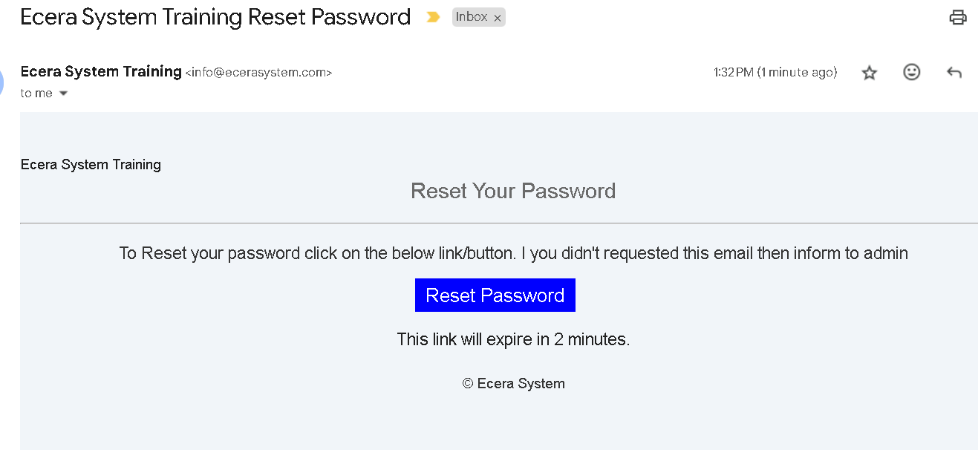

After clicking on reset password link <https://citria.org/reset-password/>

You will get following window where you can rest your password.

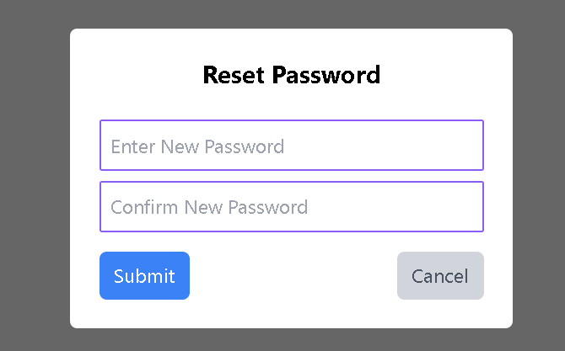

After resetting the password you will be redirected to the sign in window, where you can sign in using new password.

